Engineering Alpha: A Definitive Framework for Algorithmic Trading Architectures with NautilusTrader

1. The Architectural Evolution of Quantitative Systems
The history of algorithmic trading infrastructure is a chronicle of the tension between developer velocity and execution latency. In the specialized domain of high-frequency and systematic trading, practitioners have historically grappled with a fundamental architectural dichotomy known in computer science and quantitative finance as the "two-language problem." This structural inefficiency stems from the conflicting requirements of the research phase versus the execution phase of the quantitative workflow.
On one side of this divide lies the research environment, predominantly dominated by Python in the modern era. The Python ecosystem, characterized by its rich tapestry of libraries such as Pandas for data manipulation, NumPy for numerical computing, and Scikit-learn for machine learning, offers an unparalleled developer experience.¹ It allows quantitative analysts, or "quants," to rapidly prototype hypotheses, visualize complex datasets, and iterate on statistical models with high velocity. The language's dynamic typing and interpreted nature facilitate exploratory analysis where speed of coding outstrips the need for raw execution speed. However, these same characteristics render Python inherently unsuitable for the nanosecond-precision, concurrent workloads required by live trading engines. The Global Interpreter Lock (GIL) effectively serializes thread execution, introducing non-deterministic latency spikes that can be catastrophic in electronic market making or high-frequency arbitrage.¹
On the other side stands the production environment, typically engineered in systems-level languages such as C++ or Rust. These languages provide the memory safety, thread management, and raw execution speed necessary to process market data feeds and submit orders within microseconds.¹ Consequently, the traditional workflow necessitates a transition from a Python prototype to a C++ production system, a process requiring a complete rewrite of the trading logic. This translation process is fraught with risk; it introduces "parity errors"—subtle discrepancies between the backtest implementation and the live execution code.¹ A logic error in translation, a difference in floating-point precision handling, or a variation in event-processing order can render a strategy that appeared profitable in simulation effectively insolvent in the live market.²
NautilusTrader emerges as a paradigm-shifting solution engineered specifically to bridge this chasm. It is not merely a backtester, nor just an execution gateway; it is a unified, event-driven trading platform that ensures Code Parity.¹ The exact strategy class, logic, and configuration files used to validate a hypothesis on historical data are deployed directly to the live trading node without a single line of code modification.¹ By leveraging a hybrid architecture where a high-performance Rust core is exposed to a Python user space, NautilusTrader solves the two-language problem, allowing quants to engineer alpha with the rigor of a systems programmer and the agility of a data scientist.²

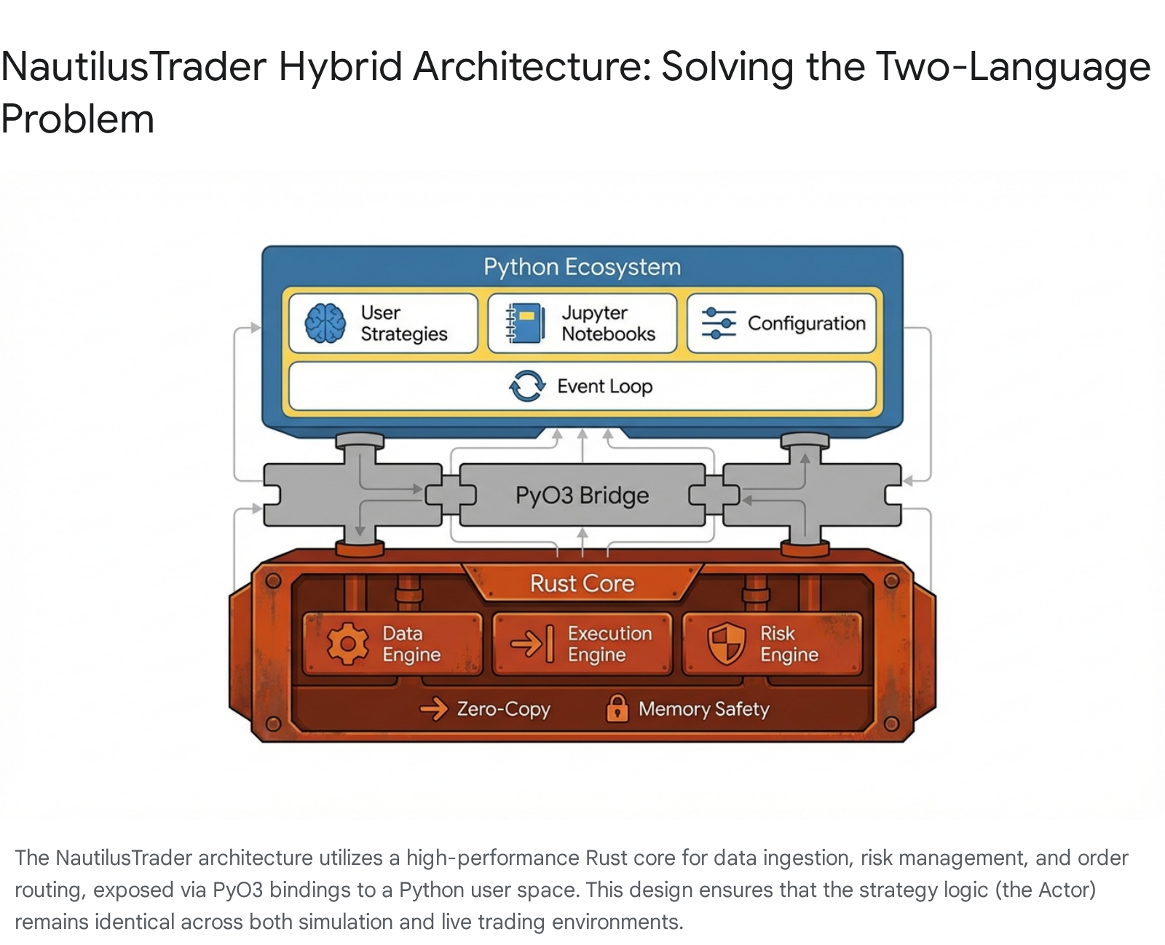

1.1 The Hybrid Runtime: Rust Core, Python Shell
The architectural brilliance of NautilusTrader lies in its hybrid design, which leverages the strengths of both Rust and Python while mitigating their respective weaknesses. The platform's core is written in Rust.¹ Rust was selected for its unique combination of high-level ergonomics and low-level control. Unlike C++, Rust guarantees memory safety without a garbage collector, eliminating the non-deterministic latency spikes that can plague Java or Go-based trading systems.¹ This core handles all the performance-critical "heavy lifting," specifically:
- Data Ingestion: Processing millions of tick updates per second from multiple venues, necessitating zero-copy deserialization where possible to minimize memory bandwidth usage.¹
- Order Book Management: Maintaining the state of Limit Order Books (L2/L3 data) with extreme precision. The core must handle the reconstruction of order books from incremental deltas, ensuring that the internal representation of the market state matches the exchange matching engine exactly.¹
- Risk Management: Performing pre-trade checks (e.g., fat-finger limits, exposure caps) in the critical path before an order leaves the gateway. Because these checks occur in the Rust layer, they add negligible latency to the execution loop.¹
Exposed on top of this high-performance engine is the Python User Space. Through the use of PyO3, a sophisticated binding library, the Rust core exposes Python objects that feel native to the developer.¹ When a user defines a strategy in Python, they are essentially scripting the behavior of the underlying Rust actor system. The communication between the two layers is optimized to minimize overhead, allowing the platform to handle HFT workloads that pure Python frameworks simply cannot touch.¹ This allows users to utilize standard Python tooling—debuggers, IDEs, and package managers like uv—while the execution semantics are handled by the binary core.⁶

1.2 Event-Driven vs. Vectorized Paradigms
To understand how to effectively engineer strategies within NautilusTrader, one must first unlearn the habits of vectorized backtesting. Platforms like VectorBT or older versions of Zipline often treat market data as a static matrix of numbers.¹ In that paradigm, a strategy is applied as a mathematical operation over an entire column of prices at once (e.g., df['close'] > df['ma']). While computationally efficient, this approach is fundamentally flawed for realistic trading simulation because it ignores the temporal causalities of the market.¹
NautilusTrader is strictly Event-Driven.¹ In this paradigm, time is not an index in an array; it is a flow of discrete events. A "Trade Tick" is an event. A "Bar Close" is an event. An "Order Acknowledgement" is an event. The system processes these events sequentially, ordered by timestamp.¹ This enforces two critical realities:
- Causality: The strategy cannot "see" the close price of the current bar until the bar acts as an event and is delivered to the on_bar handler. This eliminates "look-ahead bias" by design, a common pitfall where a backtest inadvertently uses future data to make current decisions.¹
- Microstructure Reality: Events like order fills are probabilistic and dependent on market depth. An event-driven engine can simulate the queue position of a limit order, whereas a vectorized engine typically assumes a fill at the close price.¹
This architecture dictates the workflow for the user: one does not write a script to "loop through a dataframe"; one writes an Actor (the Strategy) that reacts to messages sent by the system.¹

2. The Data Engineering Pipeline
A trading algorithm is only as robust as the data it consumes. In NautilusTrader, data is not treated as a second-class citizen or a loose collection of CSV files; it is a strictly typed, schema-enforced asset managed by a dedicated Data Catalog.

2.1 The Parquet Data Catalog Architecture
NautilusTrader eschews the common practice of storing data in loose text files or SQLite databases in favor of Apache Parquet.¹ Parquet is a columnar storage format optimized for write-once, read-many analytic workloads. The choice of Parquet is driven by three key factors:
- Compression: Financial time-series data is highly repetitive (e.g., timestamps increment regularly, instrument IDs are constant). Parquet's run-length encoding and Snappy/Zstd compression can reduce file sizes by over 90% compared to CSV, allowing massive datasets—spanning years of tick data—to fit on standard disk arrays.¹
- Columnar Access: If a backtest only requires the "Close Price" and "Volume" of an asset, the engine can read strictly those two columns from the disk, ignoring the others. This drastically reduces I/O throughput requirements, which is often the bottleneck in large-scale simulation.¹
- Schema Enforcement: The ParquetDataCatalog enforces that a "price" is stored as a specific integer type (scaled decimal) and not a floating-point number. This prevents precision loss inherent in IEEE 754 floating-point arithmetic, ensuring that a price of 100.01 is stored and processed exactly, without drift.¹

2.2 Instrument Definitions and Symbology
Before a single byte of market data can be ingested, the system requires a precise definition of the Instrument. This concept often confuses practitioners migrating from simpler platforms where a string like "BTCUSDT" suffices. In NautilusTrader, an Instrument is a rich object containing the venue's specific rules.¹ It defines the Tick Size (the minimum price increment), the Lot Size (the minimum quantity increment), and the Price Precision.
You cannot process data without an Instrument because the system needs to know how to interpret the raw numbers. For example, does a raw integer value of 5000000 represent 50,000.00 (scale factor 2) or 5.000000 (scale factor 6)? The Instrument definition holds the key.¹ The most reliable method for creating these definitions is to fetch them directly from the exchange API using the provided instrument providers (e.g., BinanceSpotInstrumentProvider), ensuring that the local definition matches the venue's reality exactly.¹

2.3 The Wrangler Pattern: Ingestion Workflow
To bridge the gap between external raw data (CSVs, REST API responses) and the internal Parquet catalog, NautilusTrader employs the Wrangler pattern.¹ A Wrangler is a specialized parser that reads raw input, validates it against the Instrument definition, and serializes it into the Nautilus internal event format.
The workflow proceeds as follows:
- Load Instrument: The Wrangler is initialized with the target Instrument ID.
- Read Raw Data: Data is loaded into a transient format, typically a Pandas DataFrame, from a CSV source.
- Process and Validate: The process() method iterates through the raw data. It validates that every price is a multiple of the tick size and every quantity is a multiple of the lot size. Invalid data points are flagged or rejected, ensuring that the Data Catalog contains only valid, tradeable events.
- Write to Catalog: The validated events are written to the catalog, automatically partitioned by directory structures (e.g., catalog/trade_ticks/BTCUSDT.BINANCE/2024/01/data.parquet) for efficient retrieval.¹

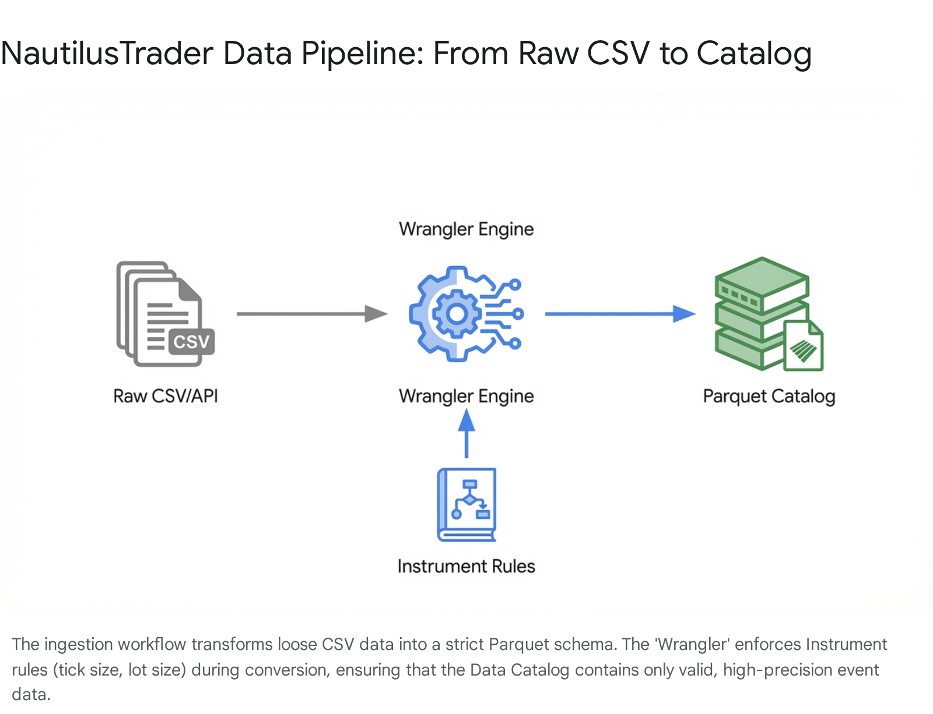

3. Strategy Development Type 1: The Python Implementation
The standard and most accessible method for developing strategies in NautilusTrader is via the Python API. This approach allows quants to utilize the vast ecosystem of Python libraries for signal generation while delegating the execution logic to the Rust backend. A strategy in this context is a Python class that inherits from the Strategy base class.¹

3.1 Strategy Structure and Lifecycle
A robust strategy is built around specific lifecycle hooks that handle events as they arrive sequentially. Understanding these hooks is paramount to correct implementation:
- on_start(self): This method is the initialization vector. It is called exactly once when the node starts. This is the correct place to subscribe to data feeds (e.g., self.subscribe_bars or self.subscribe_trade_ticks) and initialize any state variables or indicators.¹
- on_bar(self, bar): The primary signal generation handler for strategies operating on aggregated data (OHLCV). It receives a Bar object containing the open, high, low, close, and volume for the interval.¹
- on_trade_tick(self, tick): A high-frequency handler called for every individual trade on the market. This is used for strategies requiring granular microstructure data.¹
- on_order_fill(self, event): Called when an order is executed. This handler is crucial for managing position state, updating internal accounting, or triggering subsequent orders (e.g., placing a stop loss after an entry fill).¹
- on_stop(self): The cleanup vector called during shutdown. It is best practice to use this hook to cancel any open orders or close positions to flatten the book before the process terminates.¹

3.2 Implementation Case Study: Mean Reversion
To demonstrate the capabilities of the Python API, we will examine the implementation of a Mean Reversion strategy. The logic dictates that asset prices tend to revert to their historical average. The strategy calculates a moving average and standard deviation; it buys when the price deviates significantly below the mean and sells when it deviates above.

3.2.1 Configuration
Hardcoding values is an anti-pattern in systematic trading. NautilusTrader utilizes a StrategyConfig class to make strategies reusable and optimizable. This configuration object is passed to the strategy upon initialization.

Python

from decimal import Decimal
from nautilus_trader.config import StrategyConfig
class MeanReversionConfig(StrategyConfig):
"""Configuration for the Mean Reversion Strategy."""
instrument_id: str
lookback_period: int = 20
deviation_band: float = 2.0
order_quantity: Decimal = Decimal("0.01")
use_brackets: bool = True

3.2.2 State Management and Signal Logic
The strategy class maintains a buffer for price history. In a production environment, one might use an efficient circular buffer or an incremental algorithm to update the mean and standard deviation, but for clarity, we use a list manipulation approach. Note the interaction with the OrderFactory, which abstracts the complexity of creating order objects.¹

Python

from nautilus_trader.trading.strategy import Strategy
from nautilus_trader.model.data import Bar
from nautilus_trader.model.enums import OrderSide, TimeInForce
from nautilus_trader.model.identifiers import InstrumentId
import statistics
class MeanReversionStrategy(Strategy):
def __init__(self, config: MeanReversionConfig):
super().__init__(config)
# Convert string ID to internal InstrumentId type
self.instrument_id = InstrumentId.from_str(config.instrument_id)
# Initialize state buffer
self.history =
def on_start(self):
# Subscribe to market data feeds
self.subscribe_bars(self.instrument_id)
def on_bar(self, bar: Bar):
# Update history buffer
self.history.append(bar.close)
# Maintain fixed window size
if len(self.history) > self.config.lookback_period:
self.history.pop(0)
# Wait for sufficient data
if len(self.history) < self.config.lookback_period:
return
# Calculate Indicators
mean = statistics.mean(self.history)
std_dev = statistics.stdev(self.history)
upper_band = mean + (self.config.deviation_band * std_dev)
lower_band = mean - (self.config.deviation_band * std_dev)
# Check for Signal
if bar.close < lower_band:
self.entry_signal(OrderSide.BUY, bar.close, mean)
elif bar.close > upper_band:
self.entry_signal(OrderSide.SELL, bar.close, mean)
def entry_signal(self, side: OrderSide, price: float, target: float):
# Check if we are already in a position to avoid stacking
if self.portfolio.is_flat(self.instrument_id):
if self.config.use_brackets:
# Submit a Bracket Order (Entry + TP + SL)
# This ensures risk management is atomic
order = self.order_factory.bracket_limit_entry(
instrument_id=self.instrument_id,
order_side=side,
quantity=self.config.order_quantity,
price=price,
tp_price=target,
sl_trigger_price=price * 0.95, # Simple 5% stop
time_in_force=TimeInForce.GTC
)
self.submit_order(order)
This Python implementation highlights the Order Factory pattern. Instead of manually instantiating Order objects and setting every field, the factory provides semantic methods like bracket_limit_entry that ensure all necessary fields for that specific order type are populated correctly.¹

4. Strategy Development Type 2: The Rust Implementation
While Python provides accessibility, the Rust Strategy API represents the frontier of high-performance engineering within NautilusTrader. Implementing strategies directly in Rust bypasses the Python Global Interpreter Lock (GIL) entirely, offering nanosecond-level responsiveness and supreme memory safety.⁴ This approach is favored for high-frequency trading (HFT), market making, and arbitrage strategies where the latency overhead of the Python-Rust boundary is unacceptable.¹²

4.1 The Case for Rust in HFT
For strategies operating at the microsecond scale, Python's overhead—specifically the cost of the interpreter loop and the serialization/deserialization of data across the PyO3 boundary—can be a bottleneck. A Rust strategy operates in the same memory space as the Data and Execution engines, allowing for Zero-Copy Access. This means the strategy can read market data directly from memory without the CPU cycles required to convert it into a Python object. Furthermore, Rust's ownership model guarantees thread safety at compile time, eliminating an entire class of concurrency bugs common in C++ HFT systems.⁴

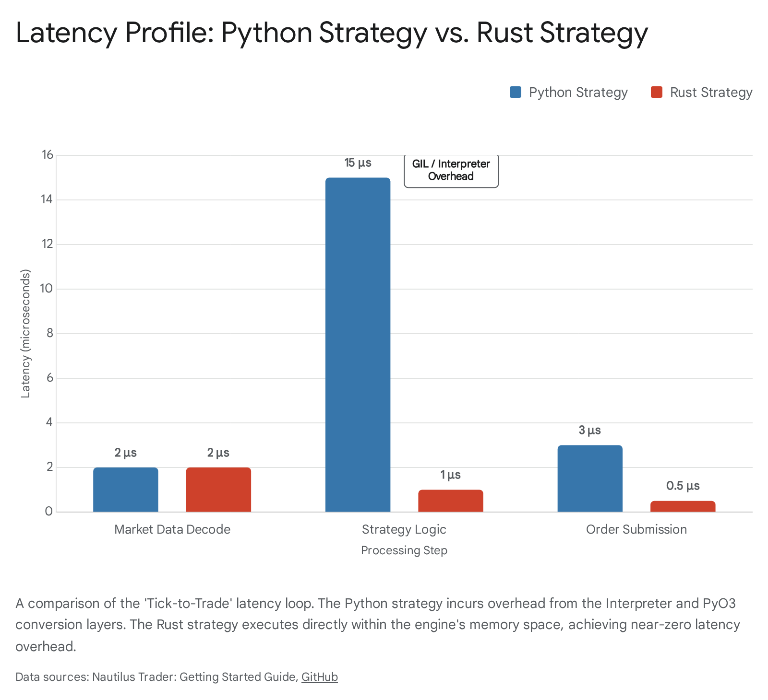

4.2 Rust Architecture and The Strategy Trait
In Rust, a strategy is implemented as a struct that implements the Strategy trait found in the nautilus-trading crate.¹³ Unlike the Python class which relies on inheritance, the Rust implementation uses trait composition. The Strategy trait defines the contract for how the actor interacts with the kernel.
Dependencies:
To build a Rust strategy, one must set up a Cargo.toml file that includes the necessary Nautilus crates. These crates are typically versioned together to ensure compatibility.

Ini, TOML

[dependencies]
nautilus-model = { version = "0.52", features = ["high-precision"] }
nautilus-trading = "0.52"
nautilus-core = "0.52"
rust_decimal = "1.29"
The nautilus-trading crate is the orchestrator, providing the Strategy trait and the StrategyContext, which serves as the gateway for the strategy to send commands (like submitting orders) back to the system.¹³

4.3 Implementation Case Study: Rust Market Maker
Below is a theoretical implementation of a simple Market Maker in Rust. This strategy listens for TradeTick events and maintains a double-sided quote (Bid and Ask) around the last traded price. This example demonstrates the explicit type handling and state management required in Rust.

Rust

// Imports from Nautilus crates
use nautilus_model::data::TradeTick;
use nautilus_model::objects::Order;
use nautilus_model::identifiers::{InstrumentId, StrategyId};
use nautilus_model::enums::{OrderSide, TimeInForce};
use nautilus_trading::strategy::{Strategy, StrategyContext};
use rust_decimal::Decimal;
/// Configuration struct for the Rust Strategy
#
pub struct RustMarketMakerConfig {
pub instrument_id: InstrumentId,
pub spread: Decimal,
pub quantity: Decimal,
}
/// The Strategy Struct (The Actor)
pub struct RustMarketMaker {
id: StrategyId,
config: RustMarketMakerConfig,
// State: Keep track of our active orders using Option for safety
active_bid: Option<Order>,
active_ask: Option<Order>,
}
impl RustMarketMaker {
pub fn new(id: StrategyId, config: RustMarketMakerConfig) -> Self {
Self {
id,
config,
active_bid: None,
active_ask: None,
}
}
}
/// Implementing the Strategy Trait
impl Strategy for RustMarketMaker {
fn id(&self) -> StrategyId {
self.id
}
/// Lifecycle hook: On Start
fn on_start(&mut self, ctx: &mut StrategyContext) {
// Subscribe to trade ticks for the instrument
ctx.subscribe_trade_ticks(self.config.instrument_id.clone());
// Log start using standard Rust macros or Nautilus logger
println!("Rust Market Maker Started: {:?}", self.id);
}
/// Event Handler: On Trade Tick
fn on_trade_tick(&mut self, tick: &TradeTick, ctx: &mut StrategyContext) {
let price = tick.price;
let half_spread = self.config.spread / Decimal::from(2);
// Calculate quotes
let bid_price = price - half_spread;
let ask_price = price + half_spread;
// Logic: Cancel old orders if they exist
if let Some(order) = &self.active_bid {
ctx.cancel_order(order.client_order_id);
}
if let Some(order) = &self.active_ask {
ctx.cancel_order(order.client_order_id);
}
// Place new Bid Order
// The context (ctx) provides methods to interact with the Execution Engine
let bid_order = ctx.submit_limit_order(
self.config.instrument_id.clone(),
OrderSide::Buy,
self.config.quantity,
bid_price,
TimeInForce::GTC,
);
self.active_bid = Some(bid_order);
// Place new Ask Order
let ask_order = ctx.submit_limit_order(
self.config.instrument_id.clone(),
OrderSide::Sell,
self.config.quantity,
ask_price,
TimeInForce::GTC,
);
self.active_ask = Some(ask_order);
}
}
Key Architectural Notes:
- Trait Implementation: The Strategy trait enforces the implementation of id(), on_start(), and event handlers like on_trade_tick().
- Context Passing: Unlike the Python self.submit_order, the Rust API typically passes a StrategyContext (ctx) into the handlers.¹³ This context is the mutable interface to the outside world, enforcing a clean separation between the actor's internal state (self) and its side effects (sending commands).
- Memory Management: The use of Option<Order> for tracking active orders forces the developer to explicitly handle the case where no order exists, preventing null pointer exceptions—a common source of crashes in C++ systems.

5. Simulation and Backtesting Methodologies
Backtesting is the scientific method of quantitative finance. It is the rigorous process of validating a hypothesis against historical data to estimate its future performance. NautilusTrader provides two distinct APIs for this purpose, catering to different stages of the research workflow: the interactive BacktestEngine and the production-grade BacktestNode.

5.1 The Low-Level API: BacktestEngine
The BacktestEngine API is designed for interactive research, typically conducted within a Jupyter Notebook environment. It provides granular control over the engine's state and allows for rapid iteration on smaller datasets.
- Workflow: The user manually loads data (e.g., from CSVs) into Python objects, occupying system RAM. This data is then injected into the engine using engine.add_data().
- Use Case: This method is ideal for prototyping logic on a few weeks of data or for debugging specific event sequences. However, because all data must reside in RAM, it is ill-suited for large-scale simulations spanning years of tick data across multiple instruments.¹

5.2 The High-Level API: BacktestNode (Recommended)
For institutional-grade simulation, the BacktestNode is the standard. It utilizes a streaming architecture that decouples data loading from strategy execution.
- Streaming Execution: When node.run() is called, the system streams data chunk-by-chunk from the ParquetDataCatalog directly into the Rust engine. This ensures that RAM usage remains constant and efficient, regardless of whether the simulation covers one week or ten years of data.¹
- Parallelism: The BacktestNode architecture supports running multiple independent backtests in sequence or parallel. This is particularly powerful for Parameter Optimization (Grid Search), where a user might want to test hundreds of variations of lookback_period or deviation_band to find the most robust configuration.¹

5.3 Microstructure Realism: The Order Emulator
A common pitfall in simpler, vectorized backtesters is the unrealistic assumption of perfect liquidity. They often assume that if the price touches a limit order level, the order is filled immediately and completely. In reality, a limit order sits in a queue behind other orders. NautilusTrader employs a sophisticated Order Emulator (Matching Engine) to simulate these dynamics with high fidelity.¹
- Latency Simulation: The emulator can be configured with a latency model (e.g., 50ms fixed delay). If a strategy submits an order, the engine delays its arrival at the matching engine by 50ms of simulation time. If the market moves away during that window, the order may miss its fill—a scenario that frequently occurs in live trading but is missed by zero-latency simulators.¹
- Fill Models: To simulate queue position, the engine supports volume-based fill models. For instance, a user can configure the emulator to only fill a limit order after a specific volume of units (e.g., 1,000) has traded at that price level after the order was submitted. This accurately models the "queue priority" mechanism of central limit order books.¹

5.4 Operational Instruction: Running a Backtest
The following Python code demonstrates how to configure and run a backtest for the MeanReversionStrategy using the high-level BacktestNode.

Python

from nautilus_trader.backtest.node import BacktestNode, BacktestRunConfig
from nautilus_trader.config import BacktestEngineConfig, BacktestDataConfig, LoggingConfig
from decimal import Decimal
import datetime
# 1. Define the Run Configuration
run_config = BacktestRunConfig(
engine_config=BacktestEngineConfig(
trader_id="BACKTESTER-001",
logging=LoggingConfig(log_level="INFO")
),
data_config=BacktestDataConfig(
catalog_path="data_catalog", # Path to Parquet files
instrument_id="BTCUSDT.BINANCE",
start_dt=datetime.datetime(2023, 1, 1),
end_dt=datetime.datetime(2023, 2, 1),
),
strategies=
)
# 2. Instantiate the Node
node = BacktestNode(configs=[run_config])
# 3. Execute
# This runs the Rust engine in the background, streaming data
results = node.run()
# 4. Analyze
# Access performance metrics like Sharpe Ratio, Drawdown, etc.
print(results.stats)

6. Live Execution and Infrastructure
The final phase of the quantitative workflow is the transition from the BacktestNode to the TradingNode. This is where the Code Parity guarantee delivers its immense value. The MeanReversionStrategy class logic remains identical; only the "plumbing" around it changes to connect to real endpoints instead of historical files.¹

6.1 The TradingNode Architecture
The TradingNode acts as the container for the live system. It manages the lifecycle of:
- Data Clients: Drivers that connect to exchange WebSockets (e.g., BinanceDataClient) to receive real-time market updates.
- Execution Clients: Drivers that connect to exchange REST/FIX APIs (e.g., BinanceExecutionClient) to submit and manage orders.
- Strategies: The user's logic actors.

6.2 Configuring for Live Trading
To trade on a live venue like Binance, one must register the specific Factories that know how to communicate with Binance's servers. Security is paramount; API keys should never be hardcoded but loaded from environment variables.

Python

from nautilus_trader.live.node import TradingNode, TradingNodeConfig
from nautilus_trader.adapters.binance import BinanceLiveDataClientFactory, BinanceLiveExecClientFactory
from nautilus_trader.config import LoggingConfig
# 1. Configuration
node_config = TradingNodeConfig(
trader_id="PROD-TRADER-001",
logging=LoggingConfig(log_level="INFO")
)
# 2. Initialize Node
node = TradingNode(config=node_config)
# 3. Register Adapter Factories
# These factories abstract the complex creation of data and execution clients
node.add_data_client_factory("BINANCE", BinanceLiveDataClientFactory)
node.add_exec_client_factory("BINANCE", BinanceLiveExecClientFactory)
# 4. Add the Strategy
# Note: This is the EXACT same strategy class and config used in backtesting
strategy_config = MeanReversionConfig(instrument_id="BTCUSDT.BINANCE",...)
node.add_strategy(MeanReversionStrategy(strategy_config))
# 5. Run
# Establishes connections, syncs Order Book, and starts the Event Loop
node.run()
When node.run() is executed, the node automatically performs a sequence of critical startup tasks: it connects to the Binance WebSocket, authenticates using the provided keys, downloads the latest Instrument Definitions (syncing tick sizes and lot sizes), reconciles the local Order Book state with the exchange, and finally calls on_start on the strategy to begin processing data.¹

6.3 Risk Management in Live Trading
In a live environment, the RiskEngine becomes the primary safeguard against catastrophic loss. Unlike a backtest where a bug simply produces a poor equity curve, a bug in live trading can drain an account in seconds. NautilusTrader allows users to configure Pre-Trade Risk Checks that are enforced in the Rust layer with microsecond latency.¹
Common checks include:
- Max Order Quantity: Rejects any order larger than a specific size (e.g., > 1.0 BTC).
- Max Notional Value: Rejects any order with a notional value exceeding a threshold (e.g., > $50,000).
- Fat Finger Limits: Rejects orders priced too far away from the current market price.
- Global Kill Switch: Automatically cancels all open orders and halts trading if the realized daily loss exceeds a defined limit.
These checks occur in the critical path, meaning an order sent by a strategy is inspected by the Rust RiskEngine before it is serialized and sent to the exchange gateway, ensuring robust operational safety.¹

7. Conclusion
NautilusTrader represents a significant maturation in open-source quantitative infrastructure. By fusing the developer velocity of Python with the systems-level performance of Rust, it successfully eliminates the "two-language problem" that has historically fragmented the industry. The platform's rigorous adherence to event-driven architecture, strict data typing, and code parity between simulation and production provides quants with a professional-grade toolkit for alpha generation. Whether implementing a standard Mean Reversion strategy in Python or crafting a bespoke, nanosecond-sensitive Market Maker in Rust, NautilusTrader offers the architectural foundation required to compete in modern electronic markets. The workflow—from wrangling Parquet data to configuring Rust-based risk checks—enforces a discipline that ultimately leads to more robust, reliable, and performant trading systems.

Works cited
- Nautilus Trader: Getting Started Guide
- nautechsystems/nautilus_trader: A high-performance algorithmic trading platform and event-driven backtester - GitHub, accessed January 29, 2026, https://github.com/nautechsystems/nautilus_trader
- Developer Guide | NautilusTrader Documentation, accessed January 29, 2026, https://nautilustrader.io/docs/latest/developer_guide/
- Rust | NautilusTrader Documentation, accessed January 29, 2026, https://nautilustrader.io/docs/latest/developer_guide/rust/
- Chapter 1: Introduction to NautilusTrader - DEV Community, accessed January 29, 2026, https://dev.to/henry_lin_3ac6363747f45b4/chapter-1-introduction-to-nautilustrader-5552
- Environment Setup | NautilusTrader Documentation, accessed January 29, 2026, https://nautilustrader.io/docs/nightly/developer_guide/environment_setup/
- NautilusTrader Grid Trading Strategy: Full Backtesting Tutorial in Python | by Aule Gabriel, accessed January 29, 2026, https://medium.com/@aulegabriel381/nautilustrader-grid-trading-strategy-full-backtesting-tutorial-in-python-9735cd3874cb
- Strategies | NautilusTrader Documentation, accessed January 29, 2026, https://nautilustrader.io/docs/latest/concepts/strategies/
- Overview | NautilusTrader Documentation, accessed January 29, 2026, https://nautilustrader.io/docs/latest/concepts/overview/
- accessed January 29, 2026, https://raw.githubusercontent.com/nautechsystems/nautilus_trader/develop/README.md
- Quickstart | NautilusTrader Documentation, accessed January 29, 2026, https://nautilustrader.io/docs/nightly/getting_started/quickstart/
- Rust for high frequency trading and backtesting. - Reddit, accessed January 29, 2026, https://www.reddit.com/r/rust/comments/1esus4t/rust_for_high_frequency_trading_and_backtesting/
- nautilus_trading - Rust - Docs.rs, accessed January 29, 2026, https://docs.rs/nautilus-trading
- Backtesting | NautilusTrader Documentation, accessed January 29, 2026, https://nautilustrader.io/docs/latest/concepts/backtesting/
- Optimizing parameters with mean reversion strategy : r/algotrading - Reddit, accessed January 29, 2026, https://www.reddit.com/r/algotrading/comments/1iq21bf/optimizing_parameters_with_mean_reversion_strategy/

